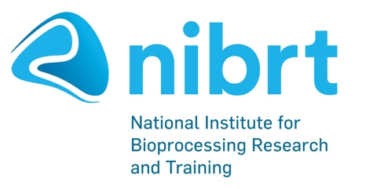

Foster Avenue, Mount Merrion, Blackrock,
A94 X099
Ireland.

Tel: +353 1 215 8100
Fax: +353 1 215 8116
Web: www.nibrt.ie

