Siemens /NIBRT research collaboration uses AI and data analytics to support biopharma production
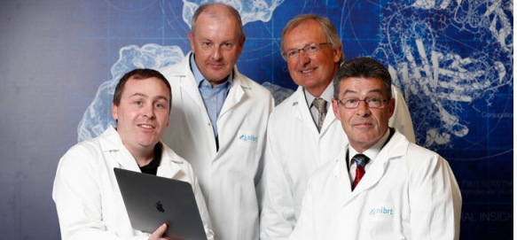
Siemens Ireland and the National Institute for Bioprocessing Research and Training (NIBRT) are collaborating in a research project for data analytics to support bio pharma manufacturing. Researchers and engineers working at the newly created application centre are using artificial intelligence and data analytics to improve understanding of manufacturing processes in the biopharma industry, with the goal of improving efficiency in drug production.
The Siemens MindSphere platform is being used to apply data-based analytics solutions to real manufacturing activities and identify potential improvements in the manufacturing process of various medicines. MindSphere is a cloud-based, open Internet of Things (IoT) operating system that connects products, plants, systems, and machines, enabling users to get more value from the wealth of data that they generate, by using advanced analytics to predict and control the manufacturing process.
NIBRT Principal Investigator, Dr Colin Clarke is leading the research team to develop solutions that incorporate state of the art data analytics approaches specifically for biopharmaceutical production improvement. The project is supported by IDA Ireland and Science Foundation Ireland.
Gary O’Callaghan, CEO, Siemens Ireland commented: “As a world leader in the fields of automation and digitalisation, Siemens recognises the opportunity of data analytics and IoT to deliver medicines at a higher quality, with consistent manufacturing processes. The Mindsphere platform will provide for increased drug production rates across multiple sites and products in a way that is scalable from the lab and pilot phases up to large scale manufacturing”.
NIBRT CEO Dominic Carolan stated: “This is an important collaboration between Siemens and NIBRT Artificial intelligence and data analytics are key technologies which will help drive efficiencies and improve quality outcomes throughout the biopharma manufacturing process. The ultimate goal is to leverage these technologies to further improve the biopharma supply chain and patient access to biopharma therapeutics”.
(Pictured left to right) Dr Colin Clarke NIBRT, Domhnall Carroll, Siemens, Dominic Carolan, NIBRT and Gary O’Callaghan, Siemens announcing the NIBRT-Siemens research collaboration

