Aaron Mertens Biography

Aaron Mertens has been a member of the STERIS Life Sciences Contamination Control Solutions as a Technical Service Manager since January 2015. In this role, Aaron has responsibility for providing global technical support primarily for Critical Environments (i.e. environmental sanitizers, disinfectants, sporicides), Sterility Assurance Products (i.e. biological and chemical indicators), and Barrier Products Solutions (i.e. sterilization wrapping), application and validation.

Previously, Aaron has held a number of positions within the Pharmaceutical Industry, specializing in cleaning, disinfection, sterilization and contamination control in parenteral drug manufacturing. In these roles, he has gained experience interfacing with industry regulatory agencies (FDA, EMEA, Japan), representing quality assurance programs.

Aaron has been a member of various industry organizations (PDA, ISPE) since 1999, contributing by presenting posters and talks at meetings, as well as participating in local chapter functions. He holds a bachelor’s degree in Genetics from the University of Wisconsin – Madison.

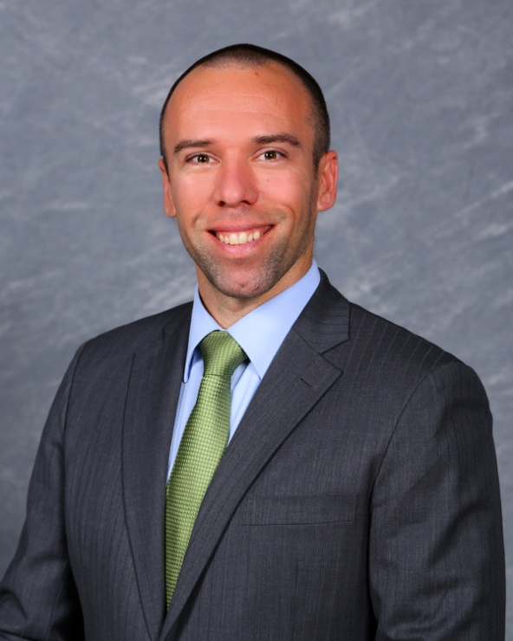 | Aaron J. Mertens  Technical Service Specialist  STERIS Corporation | Life Sciences  440-354-2600 | 800-444-9009  Mobile: 440-530-0060  E-Mail: Aaron_Mertens@steris.com

Speaker Info: Joe McCall, SM (NRCM)

Joe is a Technical Service Specialist with STERIS Life Sciences. He specializes in microbial control, environmental monitoring, contamination investigations and cleanroom issues. Joe has over 20 years of experience in the biopharmaceutical and medical device industries, specializing in aseptic processing, cleanroom qualification, environmental monitoring, and risk management. He is based in South Carolina USA and provides global technical support and expert consultation services for Critical Environments. Joe is an invited conference speaker on pharmaceutical microbiology topics at Pharmaceutical Microbiology Forum (PMF), PDA, A3P Belgium, ISCC, and course instructor at NIBRT Ireland and the University of Tennessee Health Science Center’s Aseptic Processing Training course. He is a vetted member of the US FDA’s Network of Experts program, an ASQ certified Six Sigma Green Belt, and is one of only 32 professional microbiologists globally to attain the American Society for Microbiology (ASM) certification as a Specialist Microbiologist in Pharmaceutical and Medical Device Microbiology.

